### How to open the Excel File

Since we used VBA in Excel to automate repetitive tasks and enhance productivity by writing custom macros or functions that perform specific actions and calculations you may need to unblock macros for the Excel file since it is blocked by default when downloading the file.

To do so, please follow these simple steps:

1- Right click on file and click properties

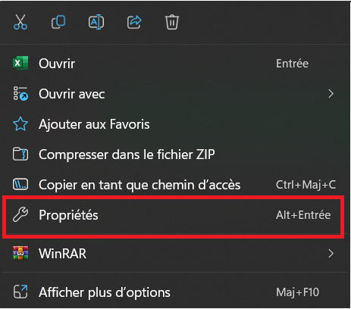

2- Select unblock and then apply

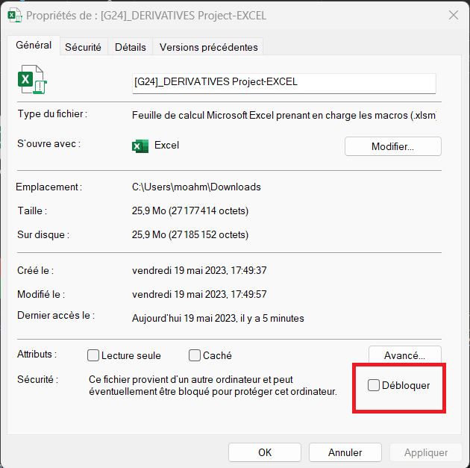

### Introduction

We were hired by Alpha Capital to assist Leasing Company TLF in mitigating their interest rate risk. In this report, we will detail the steps we took to help the company manage its risk exposure and design a swap contract to protect against fluctuations in interest rates.

### 

### Steps 1-3: Choosing and Contacting Leasing Company and Proposing Services

After conducting research on several leasing companies, we reached out to them through various channels such as physical meetings, e-mails, and phone calls. Out of all the companies we contacted, only Hannibal Leasing and Tunisie Leasing et Factoring responded to our proposal to help them mitigate their interest rate risk.

Despite Hannibal Leasing's initial response, we encountered an issue with the data they provided, and they did not respond to our request for the correct information. As a result, we chose to work with TLF, who was cooperative in providing us with the necessary data we needed to proceed with our analysis.

We first went to the TLF building. There, we were greeted by Mr. Kamel Krimi who proceeded to explain to us the interest rate risk that the leasing companies may face and the instruments they use to hedge against it. Then, we started talking to him about the project and explained the intricacies of the swap agreement and how it can be a very useful tool for them in order to neutralize their exposure to risk. He was very understanding and pointed us to Mr. Bassem Argoubi, the finance manager, and said that he would be the one to guide us throughout our project. We headed for Mr. Bassem’s office where he welcomed us. We started pitching him the idea and requested him to give us the data we need for our calculations. He expressed his interest in the idea and highlighted that zero-coupon rates do not truly represent their true cost of capital, thus we need to add a risk premium when we discount the cash flows in the calculations. We highlighted this amount later in this report.

We would like to express our gratitude to Mr. Bassem AGROUBI of Tunisie Leasing & Factoring for his assistance in acquiring the relevant data.

### Step 4: Computing Interest Rate Risk

**Note: All the contracts (assets and liabilities) are monthly compounded.**

When we first received the spreadsheets, we sat down and discussed how we could proceed with our calculations.

We decided on to start by organizing our excel spreadsheet and add the data we need. We had to visit Tunisie Clearing’s website and download the zero-coupon rates needed to discount the cash flows. As our the frequency of our payments is monthly, we had to interpolate the missing values using this formula:

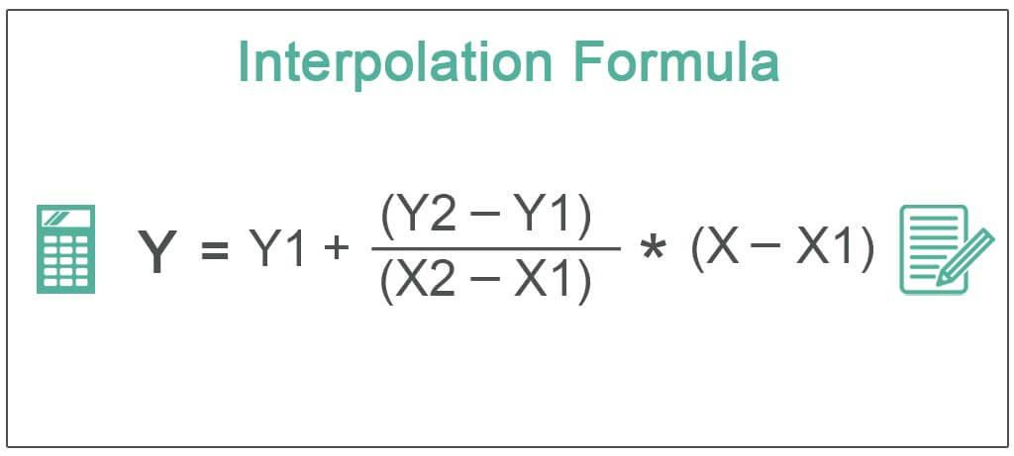

Later we calculated the maturities of each loan and since a part of the loans was already received or paid for, we chose **31/03/2023** as our starting date and calculated the Macaulay Duration as of that date.

**Maturity in months and rounded to the nearest month = Ending date - (31/03/2023).**

Afterwards, we computed the monthly cash flow (payment) of each asset & liability.

This is the formula used to do so:

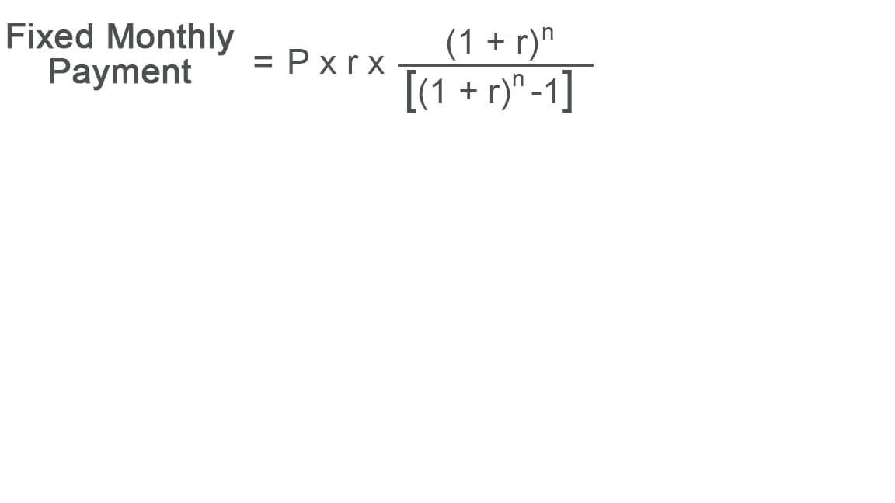

Where:

**P**: Principal amount. **r**: Interest rate. **n**: Maturity in months.

As for the Macaulay Duration, we coded a function as a VBA Macro to help us compute the durations efficiently, this is the code of the function “MacDuration” created:

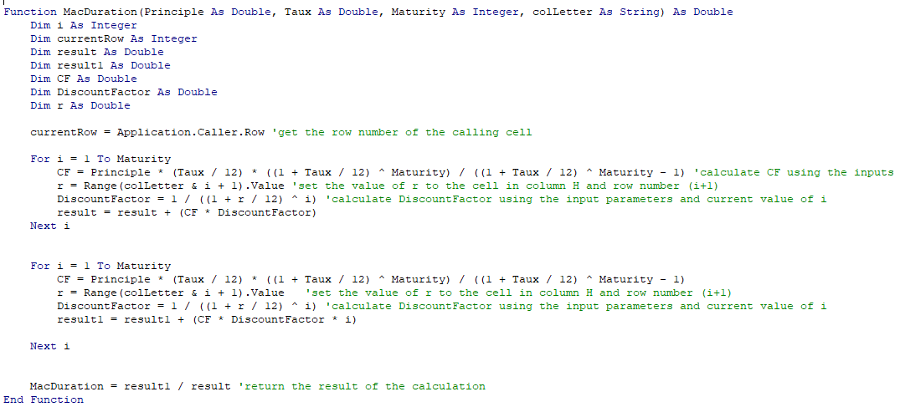

The MacDuration() function takes in 4 parameters: principle, interest rate, maturity in months, and the name of the column of the rates that will be used to discount the cash flows. (Which is the zero-coupon rate + judgemental risk premium).

Then there is a loop, where at each payment time it calculates the payment amount (which is fixed for every contract) and then discounts the it to t=0 (31/03/2023 in our case), and finally they are all summed in ‘result1’ and multiplied by the period. (1,2,3 etc…)

Afterwards, it starts another loop to compute the same thing except at the end it won’t multiply by the period. We end up with ‘result’.

The final value is (result1/result)/12. (It’s divided by 12 because the value of the duration is in months.)

All of our work is is based on this formula :

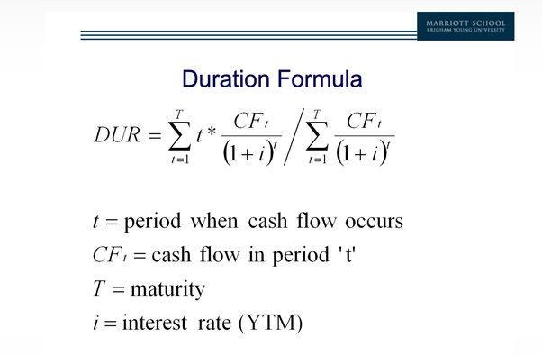

Where:

**i**: The zero-coupon rate + a judgemental risk premium.

**Judgemental risk premium:** For the discount rates, we used Tunisie Clearing’s zero coupon bond rates plus a judgemental spread of 3%.

To compute the interest rate risk, we began by calculating the duration of TLF's resources. This involved analyzing their existing fixed and floating rate liabilities, including loans and bonds, to determine the time-weighted average of the cash flows associated with each.

The duration of resources/allocations is the weighted-average of all durations with **weights** calculated by dividing the principal of each contract by the sum of all principals.

Duration of Resources:  **1.076 Years.**

Next, we calculated the duration of TLF's credit contracts, or the time-weighted average of the cash flows associated with their fixed and floating rate loans to clients.

Duration of Allocations: **1.4569 Years.**

Using these values, we then calculated the net duration of TLF's portfolio.

Net Duration = Duration of Assets - (Total Liabilities/Total Assets)*Duration of Liabilities

= **0.62 Years**

The (Total Liabilities/Total Assets) ratio acts as a scale factor to reflect the difference in market value between the assets and liabilities.

Because the duration gap embraces both the assets and liabilities and reflects the difference in market value between the two, it summarizes the entire risk position of the firm.

The net duration is positive, which indicates that the duration of the assets exceeds the duration of the liabilities.

The net duration equals 0.62 years, which means the leasing’s position behaves like a long position in a bond having a duration of 0.62 years.

⏩ To hedge the entire value of the firm, TLF could use a pay-fixed swap to set the net duration of the entire firm, including the swap, so that it equals zero.

**PS: The EXCEL File attached has the module MacDuration pre-imported in it. If the #VALUE Error comes up in the Duration Column, just refresh the values.**

### 

### Step 5: Designing a Swap Contract

To design the swap contract for TLF, we followed these steps:

1. Tenor: We chose a tenor of **5 years** for the swap with annual payments.
2. We calculated the following: -Fixed cash flows (notional*swap rates/Nb of periods per year. Floating cash flows (Notional *Forward rate/Nb of periods per year). Net duration which is the sum of them both. Discounted cash flows to t=0 using the zero-coupon rates (Net cash flow*EXP(-zero coupon rate*Period)). The value of swap at t=0 is equal to the sum of the discounted net cash flows.
3. Calculating the swap duration: As the swap duration is not affected by the notional, we used a random notional as a proxy to calculate it. **(-3.158 Years).**

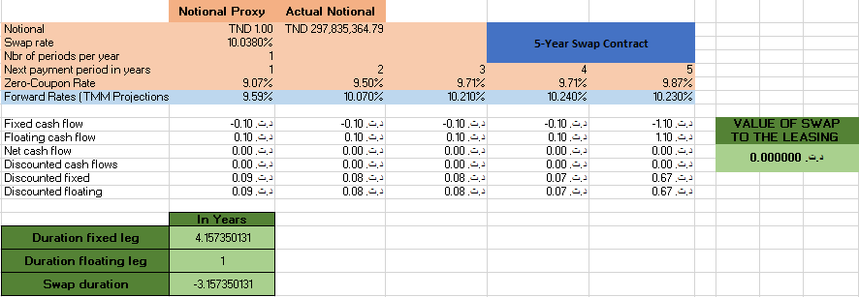

The duration of the fixed-leg instrument was calculated by dividing the (discounted fixed cash flows*period) by the discounted fixed cash flows.

The duration of a floating-rate instrument equals the time between reset dates for the interest rate. Thus this swap contract has a duration equal to 1 year.

Swap duration = Duration of floating leg (What they will be receiving)-Duration of fixed leg (what they will be giving up).

1. Calculating the actual notional: Based on our swap duration & net duration, we determined the appropriate notional **(TND 297,840,364.79).**

In general, the solution for hedging an existing asset with hedging vehicle, S, using the duration approach is given by:

**DND x MVA + DS x MVS = 0**

Where:

**DND**: Net Duration, the amount by which we would like to reduce our asset duration..

**DS**: Duration of our swap.

**MVA**: Market Value of Assets.

**MVS**: The notional of our swap.

We solved for the MVs and we found the value to be **TND 297,840,364.79**.

We then changed the value of the notional proxy cell to this amount to reflect this value in our cash flow calculations.

1. Solving for the swap rate: We used the Excel Solver Tool to solve for the swap rate that sets the value of the swap initially equal to 0. The appropriate rate is **10.03%**
2. Choosing floating rates: We selected the **TMM** as the floating rate for the swap contract that would effectively hedge TLF's interest rate risk. We used the Forward Rates (TMM Projections) for the next 5 years available on Tunisie Clearing’s website: <https://www.tunisiayieldcurve.tn/public> (Taux Forward)

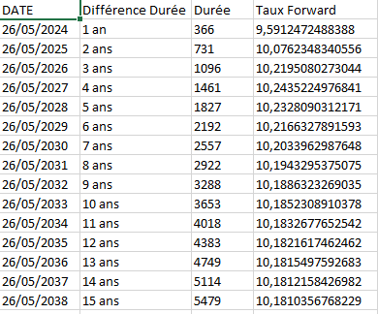

We then decided to make a second swap contract that has semi-annual payments and a floating rate of TMM -2%. We followed the previous steps by interpolating between missing values of forward rates and ended up with the following Contract:

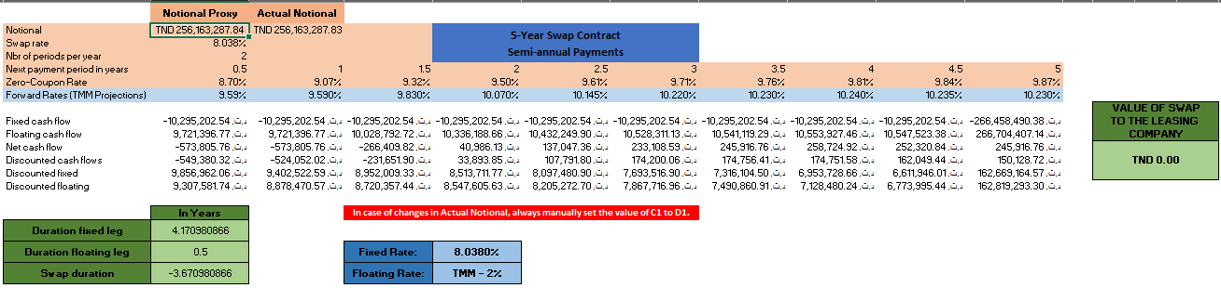

**Note: for the second swap contract, the interest rate of the floating leg resets every half-year, thus the floating leg duration is 0.5 years.**

Overall, we designed 2 customized swap contracts that would effectively mitigate TLF's interest rate risk and provide them with the necessary protection against fluctuations in interest rates and giving the bank the chance of gaining in case of TMM not increasing exponentially.

### Step 6: Preparing a Presentation for the Bank

To pitch the swap contract to a bank, we prepared a detailed PowerPoint presentation that explained the benefits of the contract and how it would help them diversify their portfolio and gain exposure to the floating rates. The presentation included a description of the swap contract's terms, as well as the potential outcomes based on the TMM projections & speculations.

### 

### Step 7: Pitching the Swap Contract to a Bank

We contacted several banks such as BNA, BH, STB and BT. But were only accepted by **BNA** and pitched them the swap contract highlighting its potential benefits for both the leasing company TLF and the bank to Mr. Lotfi Trabelsi. They directed us to the Financial Markets Professional Wassim ATTIA to continue our negotiations.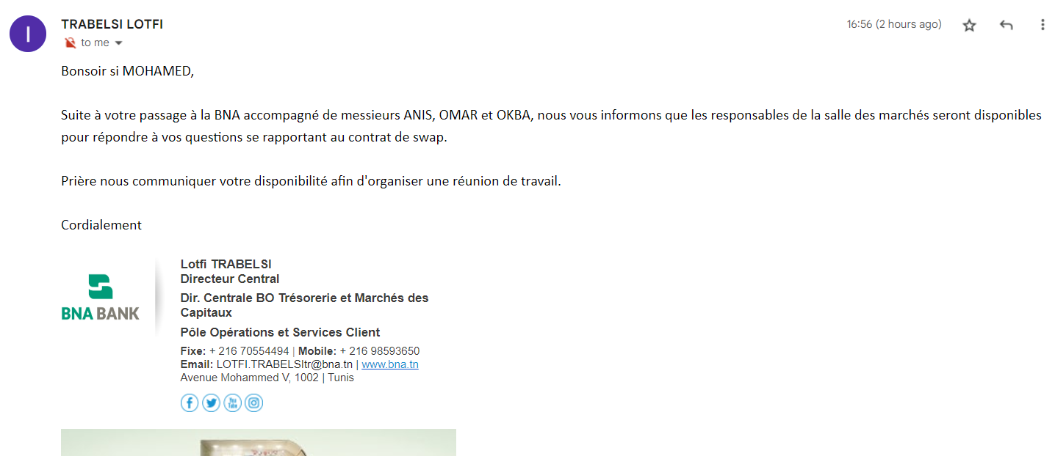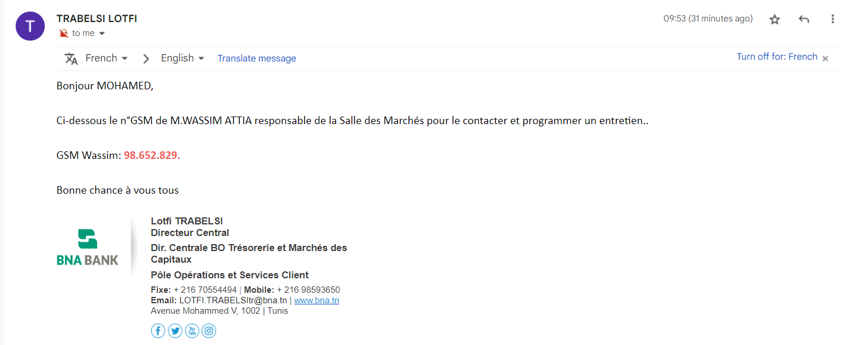

### Step 8: Negotiating Pricing with the Bank

After further discussion with the Financial Markets Professionals about the swap contract, its potential benefits to the bank and how they can gain from interest rate fluctuations, they agreed that the swap is an interesting concept that could benefit both parties. But the contract is something they’ve never tried before and would not want to risk it according to their policies and estimations. In conclusion, BNA refused to undertake the contract and enter the swap.

### Step 9: Presenting the Bank Proposal to Leasing Company

Finally, we contacted TLF again explaining the bank's decision of the swap, and our initially created contracts. They showed appreciation for our work and liked the concept of the swap, hoping to do further business in the future with us.

### Conclusion

Through this project, we were able to aid Tunisie Leasing et Factoring mitigate its interest rate risk through the use of a customized swap contract. By working closely with the company and the bank, we were able to design and implement a solution that met the company's specific needs and provided significant benefits for all parties involved.